Jordan Whittington and Adam Boehnlein

1. An array appears like this in the memory

|  |  |  |  |  |  |
| --- | --- | --- | --- | --- | --- |
|  |  |  |  |  |  |

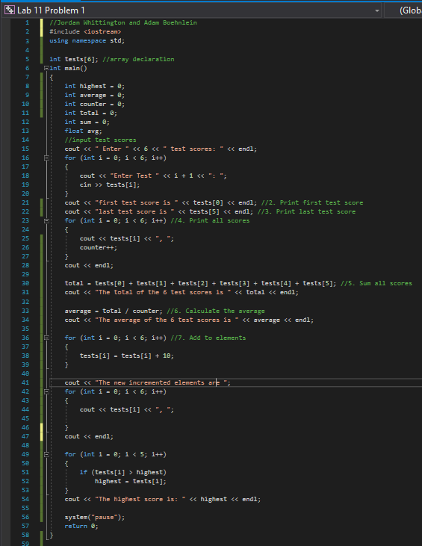

Lab 11 Problem 2

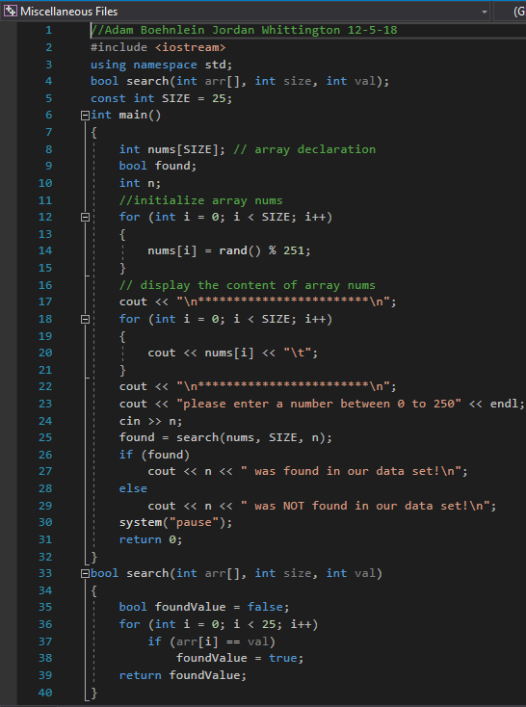

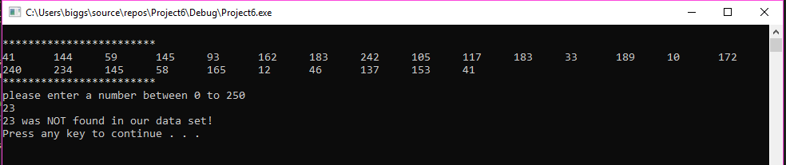

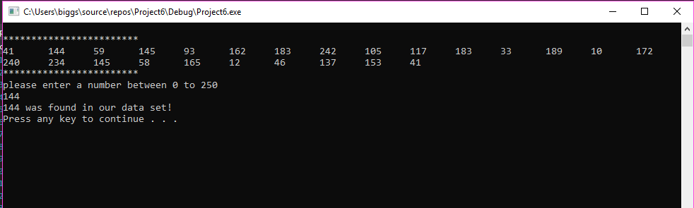

Lab 11 Problem 2 Modified

